**Enterprise Resource Planning**

*Of*

**ZAB**

**Training User Manual**

**(SV–12.3.1 | MV–1.0.0)**

**For**

**Intercontinental Dhaka**

**Leave Management**

**Index**

|  |  |
| --- | --- |
| **About** | **Page No.** |
| * Leave and Tour Application | **03** |
| * Leave and Tour application (Admin) | **04** |
| * Leave Approval | **05** |
| * Leave Confirm | **06** |
| * Leave Cancel | **07** |
| * Leave Codes & Process | **08-14** |
| * Reports | **15** |

1. **[Leave and Tour Application](http://192.168.1.17:8090/zab/login?screen=opdoheader&option=Invoice+Entry&menuname=op)** [(For each user)](http://192.168.1.17:8090/zab/login?screen=opdoheader&option=Invoice+Entry&menuname=op)

|  |  |
| --- | --- |
|  | Casual leave more than 3 days are not allowed in 1 month |
| **Step 1** | Open System **>** Leave Management > Leave and Tour Application |
| **Step 2** | Choose a Type of application (Leave Type) from Used & Available Leave dashboard. |
| **Step 3** | Pick Start Date, End Date |
| **Step 4** | Write Contact No. during Leave, Task Assigned person ID & Reason of Leave |
| **Step 5** | Click **Add** |
| **Step 6** | After being Confirmation, click **Apply** button to apply for Leave |
| **Result** | The Applied Leave notifications will be shown on Superior’s Dashboard. |

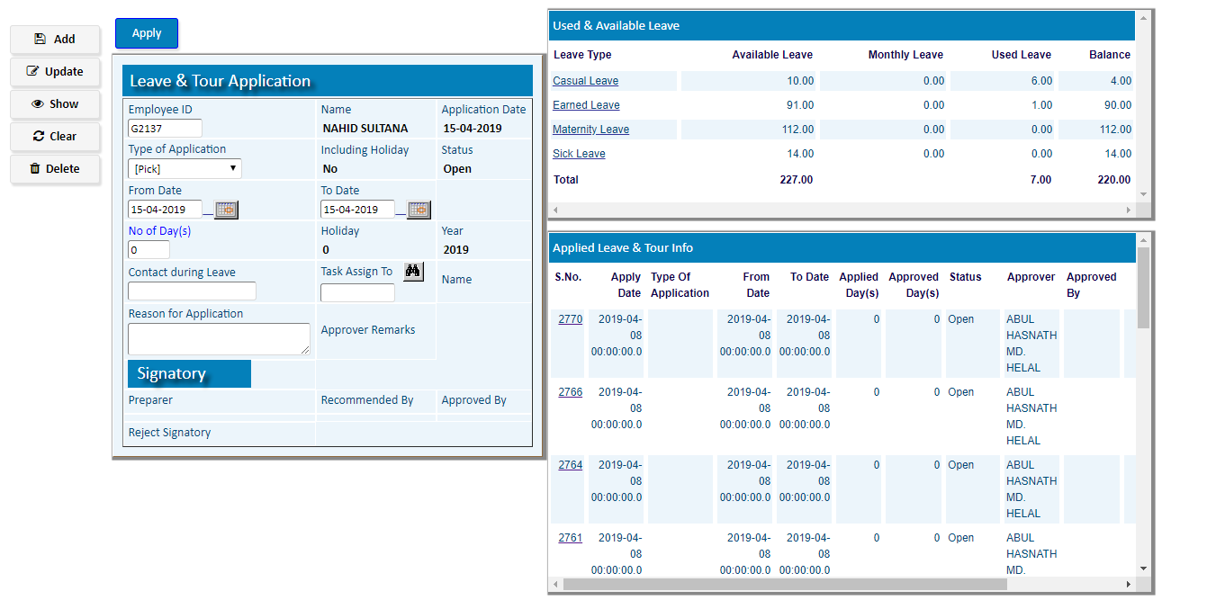

1. **[Leave and Tour application (Admin)](http://192.168.1.17:8090/zab/login?screen=opdoheader&option=Invoice+Entry&menuname=op)**

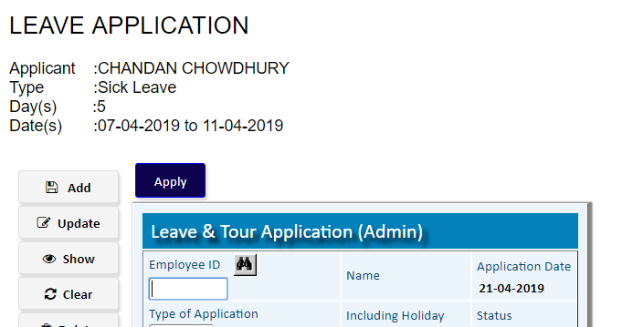Applied Leave Info

(Superiors can apply leave for staff by this option)

(Casual leave more than 3 days are not allowed in 1 month)

|  |  |
| --- | --- |
| **Step 1** | Open System **>** Leave Management > Leave and Tour Application(Admin) |
| **Step 2** | Choose Employee ID |
| **Step 3** | Click **Add** |
| **Step 4** | Choose a Type of application (Leave Type) from Used & Available Leave dashboard. |
| **Step 5** | Pick Start Date, End Date |
| **Step 6** | Write Contact No. during Leave, Task Assigned person ID & Reason of Leave |
| **Step 7** | Click **Update** |
| **Step 8** | After being Confirmation, click **Apply** button to apply for Leave |
| **Result** | The Applied Leave notifications will be shown on the Superior’s Dashboard for Approval. |

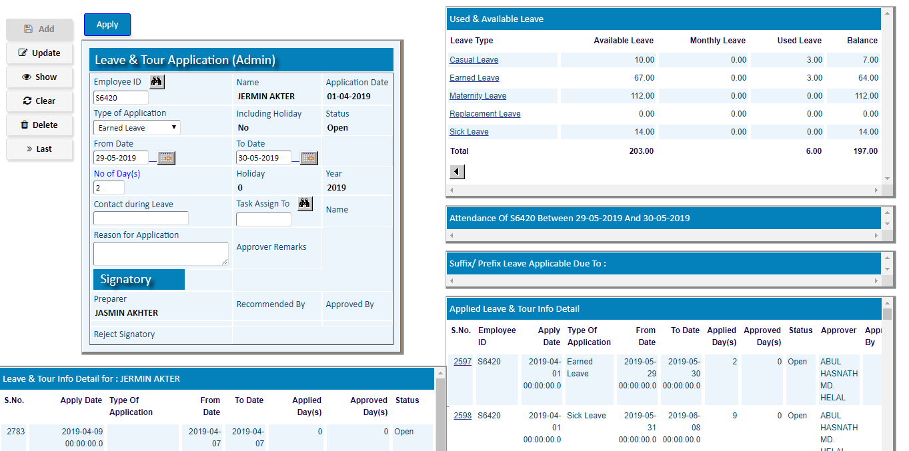

1. **Leave Approval**

(Superiors can Approve/Regret Applied leave of Staff)

Day wise Leave Approval

|  |  |
| --- | --- |
| **Step 1** | Open System **>** Leave Management > Leave Approval |
| **Step 2** | Pick an applied Leave application from Leave & Tour Detail for Approval dashboard. |
| **Step 3** | Click **Approve** to approve the leave (to approve partially modify start date / end date) |
| **Step 4** | Click **Regret** to Reject the leave |
| **Result** | The Applied Leave will be Approved/Rejected |

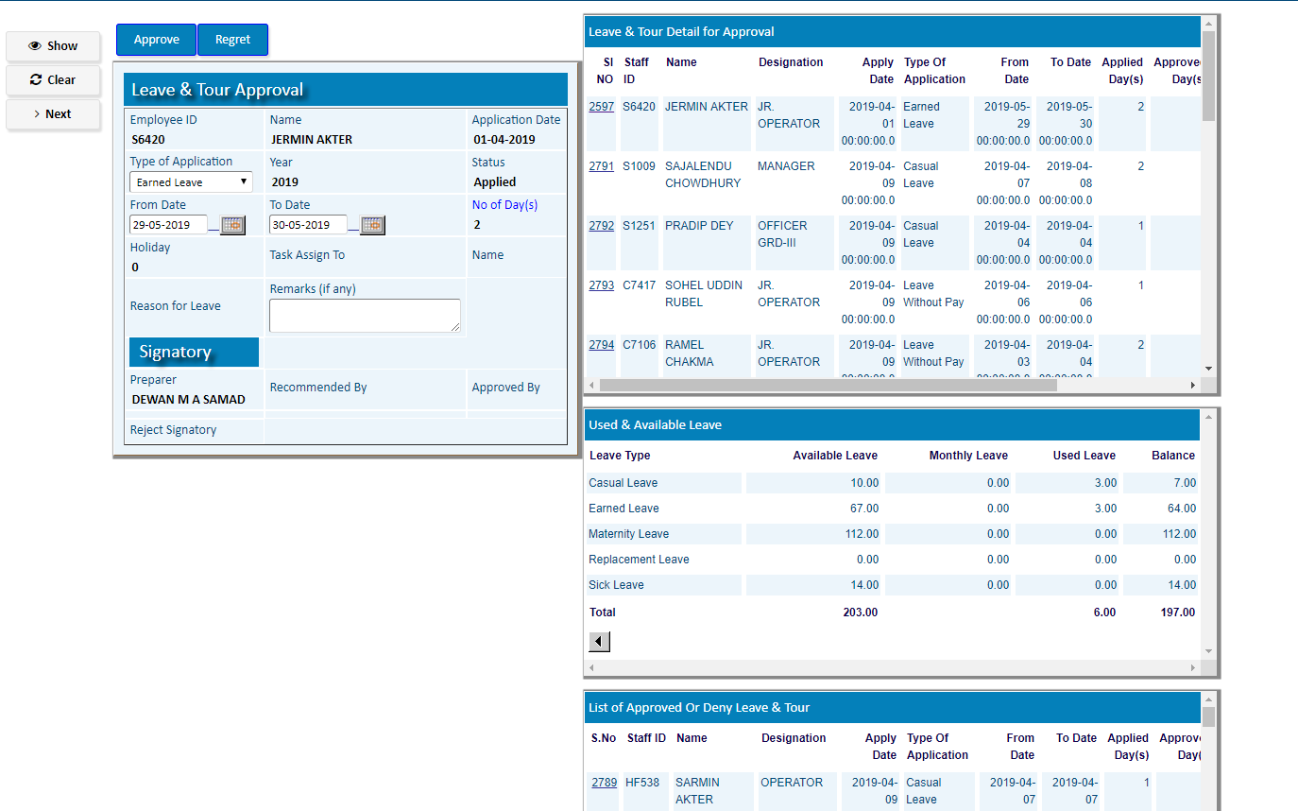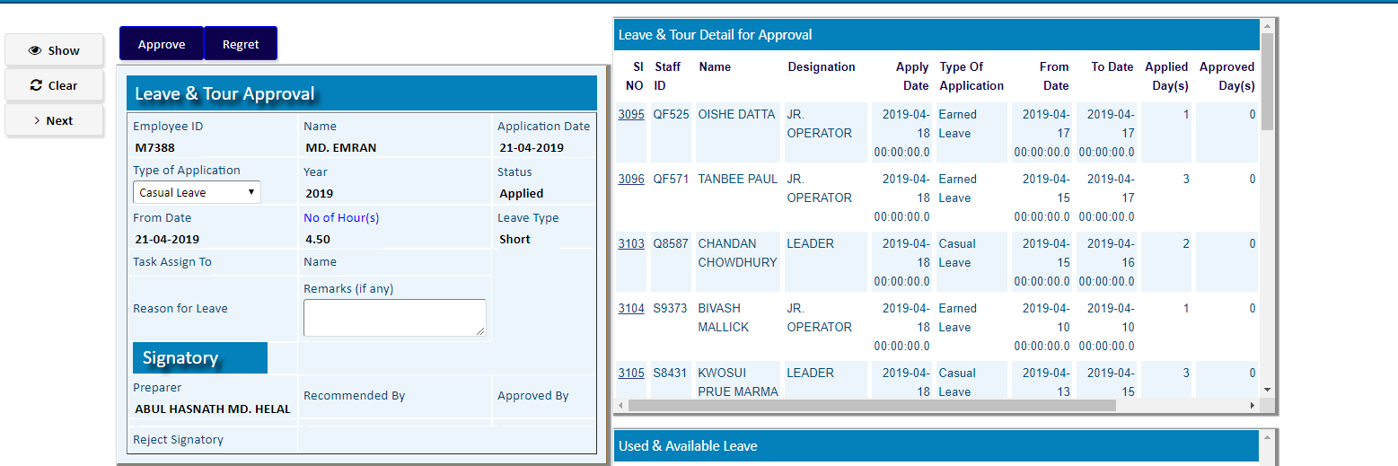

Hourly Leave Approval

1. **Leave Confirm**

(Superiors can confirm any Approved leave of Staff)

|  |  |
| --- | --- |
| **Step 1** | Open System **>** Leave Management > Leave Confirm |
| **Step 2** | Pick an Approved Leave from Leave Detail for Confirmation dashboard. |
| **Step 3** | Click **Confirm** to confirm the Approved leave |
| **Result** | The Approved Leave will be Confirmed |

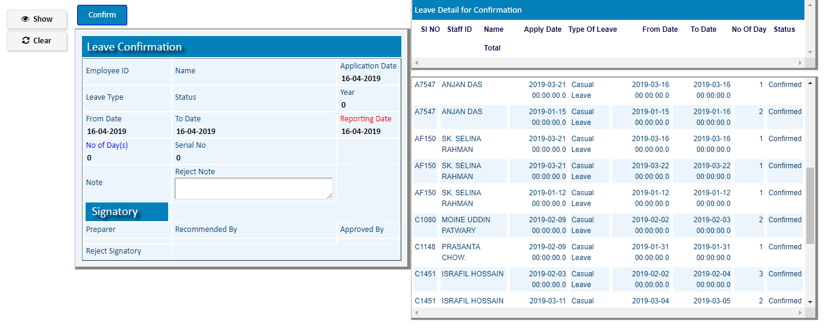

1. **Leave Cancel**

(Superiors can Cancel Partial/Full any Confirmed leave of Staff)

|  |  |
| --- | --- |
| **Step 1** | Open System **>** Leave Management > Leave Cancel |
| **Step 2** | Select Application Serial No. & then Click **Show** button. |
| **Step 3** | If Cancelation is Partial, Modify From Date & To Date of Cancelation, then Click **Cancel_Partial** |
| **Step 4** | If Cancelation is Full, Click **Cancel_Full** |
| **Result** | The Confirmed Leave will be Canceled Partially/Full |

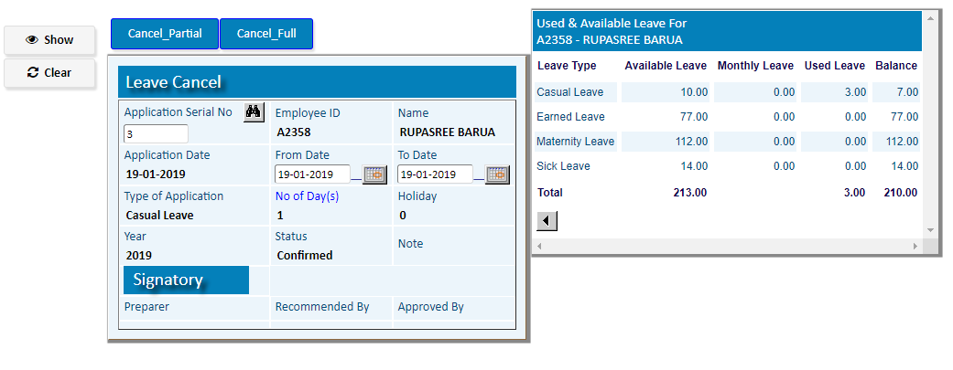

1. **Leave Codes & Process**

**) **Leave Type**

|  |  |
| --- | --- |
| **Step 1** | Open System **>** Leave Management > **Leave Codes & Process > Leave Type** |
| **Step 2** | Write a type of Leave, Choose Earned Only , Over Balance & Include Holiday |
| **Step 2** | Check ***Active*** |
| **Step 3** | Click **Add** |
| **Result** | A new Leave Type will be added |

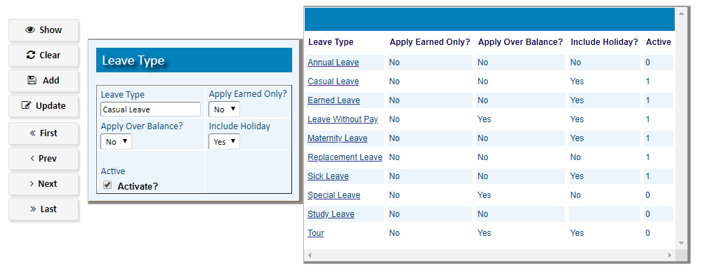

**) [**Leave Plan Master**](http://localhost:8080/zab/login?screen=pdlplanehd&option=Leave+Plan+Master&menuname=pdleave)

|  |  |
| --- | --- |
| **Step 1** | Open System **>** Leave Management > **Leave Codes & Process > Leave Plan Master** |
| **Step 2** | Write Plan Name |
| **Step 2** | Click **Plan Detail** |
| **Step 3** | **Add** leave types One by one. (Fix Day/Hour) |
| **Result** | A new Leave Plan will be added |

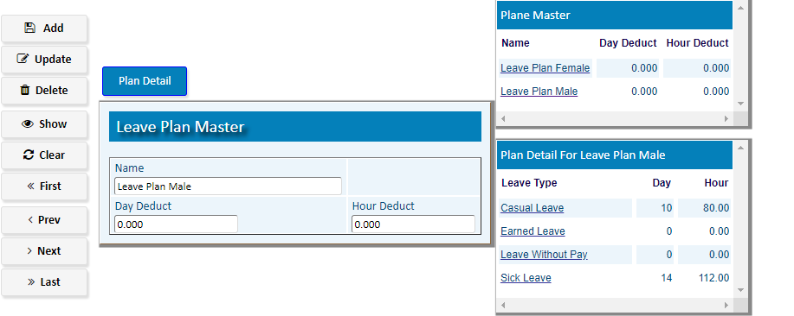

Click **Return TO Plan Master** after Adding Leave Types

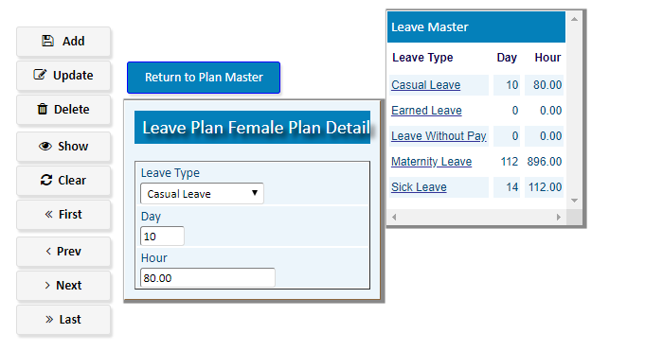

**) [**Calendar**](http://localhost:8080/zab/login?screen=pdlplanehd&option=Leave+Plan+Master&menuname=pdleave)

***Header***

|  |  |
| --- | --- |
| **Step 1** | Open System **>** Leave Management > **Leave Codes & Process > Calendar** |
| **Step 2** | Write Year & Assign Holiday(Weekend) |
| **Step 3** | Click **Add** |
| **Step 4** | Click **Create Weekend** |
| **Result** | Weekends of the year will be created |

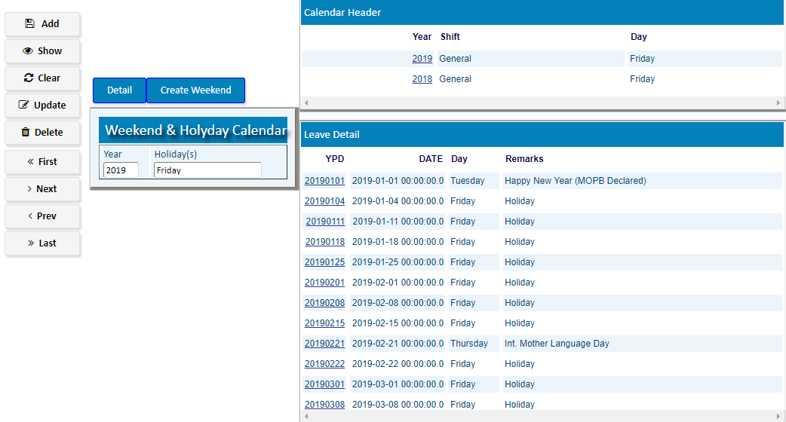

***Detail***

|  |  |
| --- | --- |
| **Step 1** | To add extra Holidays Click **Detail** |
| **Step 2** | Pick a date & check Additional Holiday (Write note if required) |
| **Step 3** | Click **Add** |
| **Result** | A new holiday will be Added |

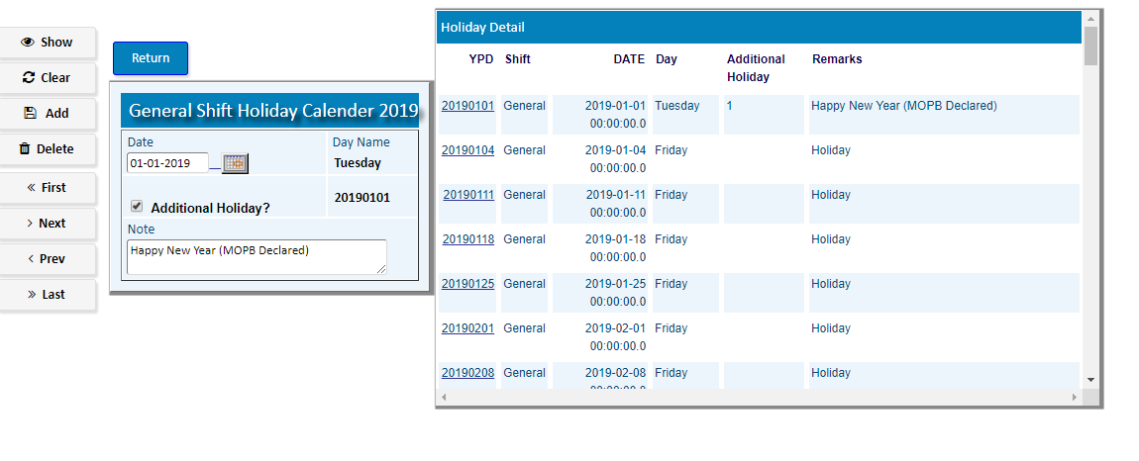

**) [**Staff Weekend (Declared)**](http://localhost:8080/zab/login?screen=pdholidayprcs&option=Staff+Weekend+%28Declared%29&menuname=pdleave)

|  |  |
| --- | --- |
| **Step 1** | Open System **>** Leave Management > **Leave Codes & Process > Staff Weekend (Declared)** |
| **Step 2** | Write the Staff ID & Fix the Year, Effective Date |
| **Step 3** | Click **Process** |
| **Result** | Weekends Of the Staff Will be added from the Effective Date |

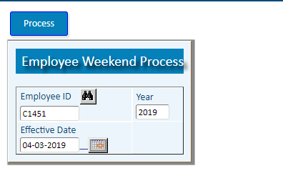

**) **Leave Process**

|  |  |
| --- | --- |
| **Step 1** | Open System **>** Leave Management > **Leave Codes & Process > Leave Process** |
| **Step 2** | Write From Staff, to Staff, Year & Employee Category |
| **Step 3** | Click **Leave Process** for full year process**/** Click **Carry Forward Process** for remain days of the year |
| **Result** | Assigned Leave of the year will be added for the specified Employees |

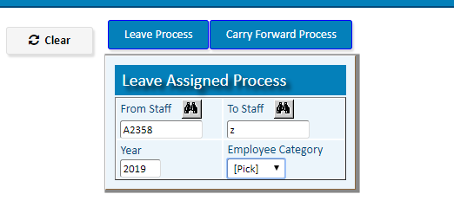

**) [**Earned Leave Process**](http://localhost:8080/zab/login?screen=pdelprcs&option=Earned+Leave+Process&menuname=pdleave)

|  |  |
| --- | --- |
| **Step 1** | Open System **>** Leave Management > **Leave Codes & Process > Earned Leave Process** |
| **Step 2** | Write From Staff, to Staff, Year & Employee Category |
| **Step 3** | Click **Leave Process** |
| **Result** | Earned Leave of the year will be added for the specified Employees |

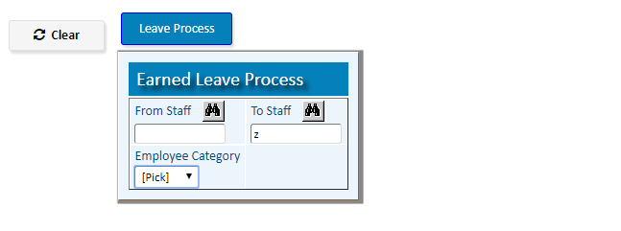

**) **Leave Assign manually**

(To Update Assigned leave for any Staff)

|  |  |
| --- | --- |
| **Step 1** | Open System **>** Leave Management > **Leave Codes & Process > Leave Assign manually** |
| **Step 2** | Write Employee ID, Lave Type |
| **Step 2** | Fix the Available Leave |
| **Step 3** | Click **Add** |
| **Result** | Leave will be assigned Manually for the Staff |

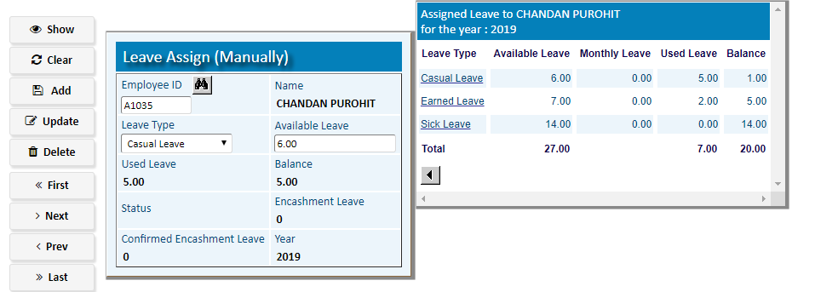

1. **Reports**

|  |  |
| --- | --- |
| **Step 1** | Open System **>** Leave Management **> Reports** |
| **Step 2** | Select the Report option to show any Report |
| **Step 3** | Write the required Parameters and then Print Repot |

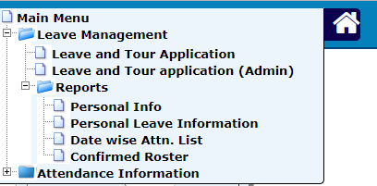

For Example >>>

**(To Show the number Assigned Leave, Used & Available Leave for the Year of any Staff)**

|  |  |
| --- | --- |
| **Step 1** | Open System **>** Leave Management **> Reports** |
| **Step 2** | Select the Report option [**Personal Leave Information**](http://localhost:8080/zab/login?screen=*viewcrystal+pdselfleaveinfo%287%3Bin%2Cst%2Cin%2Cst%2Cst%2Cst%2Cst%3Bzid%2Cstaff%2Cyear%2Crpttype%2Cempcat%2Cadminid%2Cleavetype%3Bxstaff%3DEmployee+ID%2Cxyear%3DYear%2Cxtyperpt%3DReport+Type%2Cxhide%3Dadmin+ID%2Cxhide%3Dadmin+ID%2Cxleavetype%3DLeave+Types%2Cxviewtype%3DReport+View%29&option=Personal+Leave+Information&menuname=pdperrpt) |
| **Step 4** | Pick the desired Staff ID, Year, Report Type(Summary, Brief, detail and then click on **View Report** Button |

